NutriWISE

*Landicho, Jephthah Jehosaphat*

*Andino, Clarence Phol B.*

*Dimailig, Cleo Angelo L.*

**Data Mapping**

Mobile Application:

*Gathering of Client’s Anthropometric Measurements*:

The involved tables here are the Client, Student, Client_Measurements. This process involves the student gathering the anthropometric measurements of the client. We can see that the student_id is included in the measurements so the professor would know which student assessed the client. The student then proceeds to the computation of the DBW, TER, protein, carbs, and fats needed by the client.

*Computation and Exchange Distribution:*

This process includes only two tables, namely the client_measurements and exchanges table. Here the students will proceed to translate and distribute the exchanges based on the clients’ given measurements, therefore dividing it into the separate food groups that will be the foundation of the meal plan.

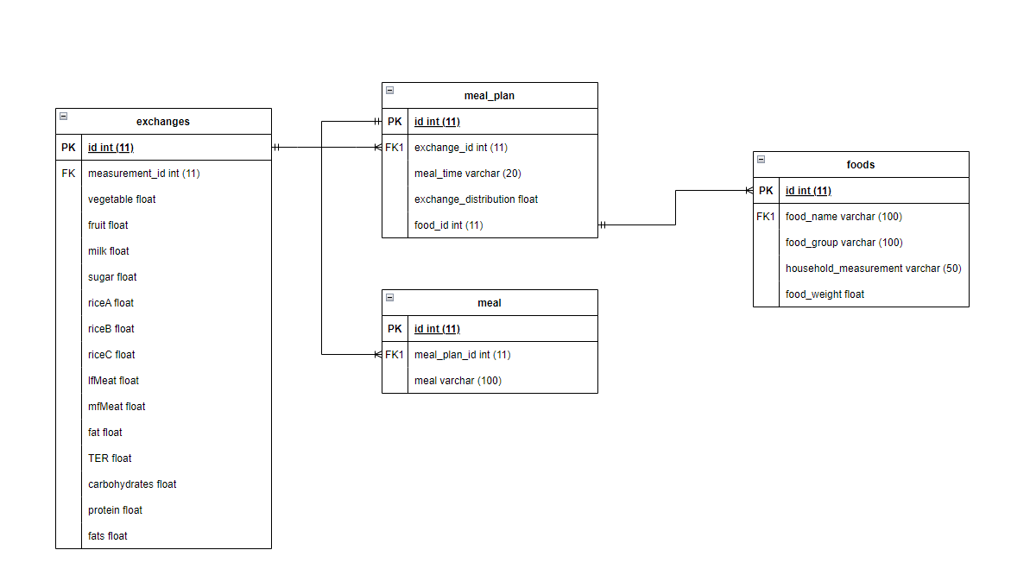

*Meal Planning:*

This process includes four tables that will be primarily used in the meal plan creation process. The foods will be chosen by the students on what’s best for their client which in turn will be included in the meal planning’s time and number of exchanges. The meal table will be used for whatever meal is going to be served on that time of the day. The exchanges table will provide the accurate number of exchanges per food group.

Web Application:

*Professor’s Class Creation:*

This process will be including the professor and classes table. This is where the professors will be creating the classes that the students will partake in. They will be giving the students’ the classes’ name and code along with the class description.

*Student’s Joining of the Classroom:*

This process will include three tables namely the student, classes, and the student_class tables. The students’ will join the classroom by referring to the class code given by their professor. And this will co-join the two tables onto one, namely the student_class table, containing both id’s of the two separate tables.

*The Classroom’s Materials:*

This process will be including the five tables namely the student, professor, student_classes, classes, and the materials. This is the process where both the professor and the students are inside the online classroom, and the professor can upload materials regarding the subject the students are enrolled in. Books, Online PDF’s, Assignments, Quizzes are the examples of what the materials table would contain.